Program Guide for
Business Lighting Trade Allies
Developed by Energy Trust of Oregon

Table of Contents
Introduction to the Program Guide 2
Revisions to the Program Guide 3
Program Overview 3
Introduction to Energy Trust 3
Program Communications 4
Program Design 4
2024 Program Requirements 4
Closed Trade Ally Network 5
Trade Ally Company Caps 5
Project and Participant Incentive Caps 5
Active Project Caps 6
Initiation Phase 11
Incentive Application Phase 11
Implementation Phase 11
Completion Phase 12
Policy Overview 12
Confidentiality of Program Participant Information 12
Providing Information to the Participant 12
Self-Direct Participants 13
Trade Ally Enrollment 13
Trade Ally Listing on Energy Trust Website 14
Maintaining Trade Ally Status 14
Trade Ally Suspension 15
Effects of Suspension 15
Trade Ally Termination 15
Effects of Termination 16

Introduction to the Program Guide
This Program Guide provides an overview of Energy Trust's Business Lighting Program (also
referred to as the “Program”) requirements, processes, and procedures. The requirements outlined in this guide are effective May 1, 2023 April 1, 2024, and any projects submitted on or after this date are subject to these requirements. Projects submitted before May 1, 2023 April 1, 2024, are subject to the previous Program Guide requirements.

Part 1 of the guide focuses on Program offerings and delivery. This section outlines specific
Program design changes for 2023 2024, describes project submission procedures and provides a general policy overview.

Part 2 of the guide covers the Business Lighting Program trade ally enrollment process and
summarizes expectations and requirements for enrolled trade allies.

Business Lighting trade allies are required to read, understand, and follow the requirements
outlined in this guide to be authorized as an Energy Trust Business Lighting trade ally. For information on becoming a Business Lighting trade ally, see Part 2, Section 4 of this guide.

Revisions to the Program Guide
Energy Trust may revise this Program Guide to reflect changes in incentive information,
requirements, procedures, or processes at any time. Once updated, Energy Trust will post a new version to the Business Lighting trade ally page. Business Lighting trade allies should check this page regularly to ensure they are using the current version of the Program Guide. Energy Trust will also announce new versions of this guide in the INSIDER, a bi-monthly electronic newsletter distributed to all enrolled Energy Trust trade allies.

Additions to the prior active version of the Program Guide will be highlighted for ease of reference. Deletions from the prior active version of the Program Guide will be stricken.

PART 1: Business Lighting Program Overview

Program Overview

Introduction to Energy Trust
Energy Trust of Oregon is an independent nonprofit organization dedicated to helping utility customers benefit from saving energy and generating renewable power. Business Lighting trade allies can read more about Energy Trust’s purpose, structure, board and advisory councils on our website.
Business Lighting trade allies are welcome to participate in Energy Trust’s public meetings. The Conservation Advisory Council, Renewable Energy Advisory Council, Diversity Advisory Council, and the Energy Trust Board of Directors generally meet every one to two months. View upcoming public meetings and agendas here.

Program Communications
Unless otherwise noted, all project review communications from Program representatives to Business Lighting trade allies will be made via email.
Email Communications
The email address for the Energy Trust Business Lighting Program is lighting@energytrust.org. To deliver documents to the Program, use lightingdocuments@energytrust.org.
Phone Communications
Call Energy Trust at 1.800.326.2917 to speak with a Business Lighting Program representative.
Mailing Address
Energy Trust of Oregon (Business Lighting)
421 SW Oak St, Suite 300
Portland, OR 97204

Business Lighting trade allies should have a thorough understanding of all Program documents. Please contact Energy Trust immediately if there are any questions about this Program Guide or any other Program documents.

Program Design
The lighting market is changing. Programs must think beyond the implementation best practices of today. Programs must recognize the rapidly evolving marketplace and design a dynamic, cost-effective way to engage with customers through varied delivery channels. It is essential to focus on efficient and accelerated lighting equipment conversions.
Energy Trust’s Business Lighting Program balances these needs, along with incentive budgets, to reach customers through different delivery channels with a variety of offers. Trade allies will use the most recent versions of Program forms and the Business Lighting Tool that are in effect to deliver the standard offering. The Program will provide trade allies notice about updates to offerings and this guide as noted in the “Revisions to the Program Guide” section.

2024 Program Requirements
Energy Trust is launching revised Business Lighting incentive offers and requirements for 2024. These changes are described in this section.
Energy Trust program requirements, including incentives, are subject to funding availability and may change. Business Lighting project requirements are contained within Energy Trust’s Incentives for Energy Efficient Lighting forms:
- Program Information – 190L
- Street Lighting – 190SL
- Public Sector Lighting – 190PS
- Horticulture Lighting – 490HL.
Trade allies are required to meet the project requirements.

Closed Trade Ally Network
Contractors must be enrolled as an Energy Trust Business Lighting trade ally in our Trade Ally Network to offer Energy Trust incentives to their customers for qualifying lighting projects. Previously, Energy Trust allowed lighting contractors outside of the network to submit projects if those projects qualified for incentives. Until further notice, Energy Trust will not accept incentive applications directly from participants for self-installed lighting projects.

Trade Ally Company Caps
Each enrolled trade ally company will not have an annual cap on the dollar amount of incentives it can submit on behalf of participants.

Project and Participant Incentive Caps
Current caps on incentives in the Lighting Tool are $499,999750,000/per project for non-Horticulture Industrial and Agricultural sites, $499,999/per project for Horticulture sites, and $499,999750,000/per project for Commercial sites. See section 3.3 on Self-Direct Participants.
A project is defined as a single Lighting Tool Application and participant which results in a unique combination of Site Location and Participant Role (i.e. tenant, landlord, property manager, owner, etc.). Some common project scenarios are illustrated below.
If a participant wants to complete a project in multiple phases, the total incentives for all phases may not exceed the total project cap for Industrial and Agricultural or Commercial projects. Energy Trust has also raised the current limits on the incentive amounts a customer can receive annually at a site for all projects (combined). Contact a Program representative if you anticipate your customer may be applying for incentives for multiple projects at a site (especially if they may each hit the $750,000 or $499,999 specified project cap during the year), so we can review and discuss annual per-site program incentive limits. For the purpose of Business Lighting program participation:
Industrial and agricultural sites are defined as: Existing facilities or businesses that process, treat, assemble, mine, produce, repackage, or bottle a product or products for outside distribution, grows something, or has a cold storage distribution center. If the site is Industrial or Agricultural the whole campus will be serviced by Production Efficiency.
Horticulture sites include indoor agricultural operations or greenhouses where plants are grown or processed. Residential sites are not eligible. See Section 1.4.5 below for details.
Commercial sites are defined as: Existing properties that are not single family residential, industrial or agricultural use. Multifamily properties and roadways are considered Commercial.

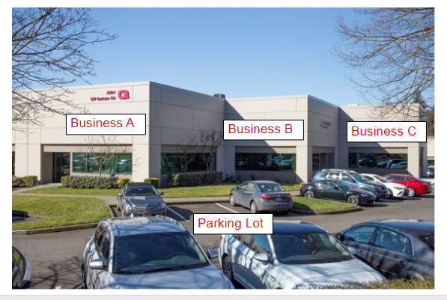
Figure 1: Shopping Plaza
In Figure 1, a Commercial shopping plaza has three leased businesses and one property manager/owner at the same address. ​Even though these four businesses have the same address, the participant role would be different for each; three unique tenants and one property owner/manager. They would be considered four different participants, each with a $499,999750,000 project cap.​
Alternatively, if three Commercial spaces are vacant and the property owner wants to upgrade the lights in all of them, then this would be considered one participant, because they both have the same address, and one participant role - the property owner. The entire shopping plaza would be considered as a single project with a $499,999750,000 project cap.
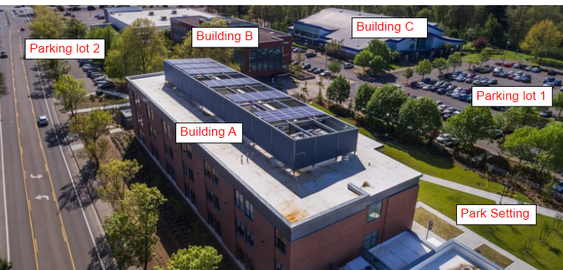
​Figure 2: Corporate Campus

Figure 2 shows a Commercial corporate campus. In this case, the entire campus is considered one location with the same participant, and is subject to a $499,999 750,000 project cap.
Please note that if a site is listed by the Oregon Department of Energy as a certified self-direct site, Energy Trust would use that site definition when reviewing a project (see Section 3.3).

Active Project Caps
A trade ally company is not limited in the number of concurrently active projects it can have with the Business Lighting Program per utility. A project is considered active from the Incentive Application Form (120L) Program Pre-Authorization Signature date until the trade ally submits the final invoice(s) and completion documents to lightingdocuments@energytrust.org If the Program does not receive a signed 120L form by the application deadline, the Program will send a project cancelation notice, which will open the trade ally company’s queue for an additional project(s) during times when an active project cap is in effect.
1.4.5 Horticulture Lighting
Energy Trust incentivizes Horticulture Lighting projects which include recreational cannabis, medical cannabis, decorative plants, food, and horticulture/hemp projects. Horticulture Lighting projects utilize custom measure incentives and are subject to additional program requirements as outlined below:
Intake form
To support project review, Energy Trust recommends trade allies complete the 400HL Intake form. The 400HL collects project information, existing environment information, and proposed upgrade fixture count. This data allows the program to work with the trade ally to determine whether the proposed project may meet Horticulture Lighting program requirements.
Eligible costs
Energy Trust makes final determination of eligible project costs for Energy Trust incentive calculation purposes. Eligible measure costs are typically calculated based on fixture costs, necessary accessories, and installation labor costs. In certain cases, only incremental costs are used in calculations. A full breakdown of available incentives can be reviewed on the 490HL.
Hours
Allowable standard hours are used by Energy Trust for Lighting Tool energy analysis for grow rooms and represent the maximum amount of time that horticultural lighting is typically operated in a registered grow space. The allowable standard hours are the maximum operating hours allowed in the program, but all stated hours should represent actual operation and, for retrofit applications, should be supported by billing data. Below are the allowable standard hours, for program purposes, per grow room:
Cannabis Lighting:
- Flower Room: 12 hours/day 7 days a week / 4,380 Annual Hours
- Full Cycle Room: 15 hours/day 7 days a week / 5,475 Annual Hours
- Veg or Mother Room: 18 hours/day 7 days a week / 6,570 Annual Hours
- Clone Room: 24 hours/day 7 days a week / 8,760 Annual Hours
- Greenhouse: Lights Supplement / Provided by the grower or industry
  - Default to 2,118 Annual Hours to extend shorter days in the year
  - Supplemental to daylight
Other Food and Decorative Plants Lighting: Hours and light levels dependent on production crop; grower or manufacturer will provide industry standard specifications appropriate to the crop.
Indoor and Greenhouse Lighting: Existing and proposed wattage will default to the input watts at 100%

Advance review and pre-qualification will be required. Please contact lighting@energytrust.org for further details.

Specific project requirements
Due to the unique structure of Horticulture Lighting, all projects are subject to the following requirements:
- Business must be registered with the State of Oregon and on the active business registry.
- Energy efficiency measures must be installed in a permanent structure. (No trailers or spaces that can be moved or relocated.)
- Site is on an eligible rate schedule with Portland General Electric or Pacific Power. If services are still pending, please contact Energy Trust.
- Facility’s primary use is industrial in nature. (Examples of eligible facilities include agriculture operations, grow or processing warehouse or plants, etc. Residential sites are excluded.)
- Site may be verified prior to ordering or purchasing materials and after installation.
Documentation Requirements:
Energy Trust requires the following documentation for all Horticulture Lighting projects:
- Required project cost documentation for horticultural lighting projects may include, but is not limited to, copies of associated purchase order(s) and project invoice(s) itemizing equipment and installation labor costs, and (when applicable) project financing or other external project funding agreement(s).
- Manufacturer or authorized reseller quote(s) itemizing price per fixture must be provided when the proposed project is submitted for review.
- Recreational Cannabis: Proof of Oregon Liquor Control Commission (OLCC) license is required for recreational cannabis producers. If OLCC license is still pending, additional documentation will be required to apply for or receive any incentives.
- Medical Cannabis: Valid Medical Marijuana Cards are required
- Horticulture & Hemp: Valid ODA license required
- Lighting Tool: Excel calculator used to submit horticulture projects
  - Project Processes
This section gives a summary of the typical project processes for the Business Lighting Program. Figure 3 is a flowchart of these processes, indicating required forms and timelines, followed by descriptions of each phase. Energy Trust reserves the right to modify these processes, including required documentation or timelines. During any phase, Energy Trust may require a participant and/or trade ally to submit additional application documentation for certain projects as necessary to enable Energy Trust to determine measure eligibility, costs, or incentive calculations. Additional required documentation may include, but is not limited to, itemized manufacturer or authorized reseller quote(s) itemizing price per fixture, trade ally project equipment purchase orders and invoices, or (when applicable) copies of any related project financing or other external project funding agreement(s).
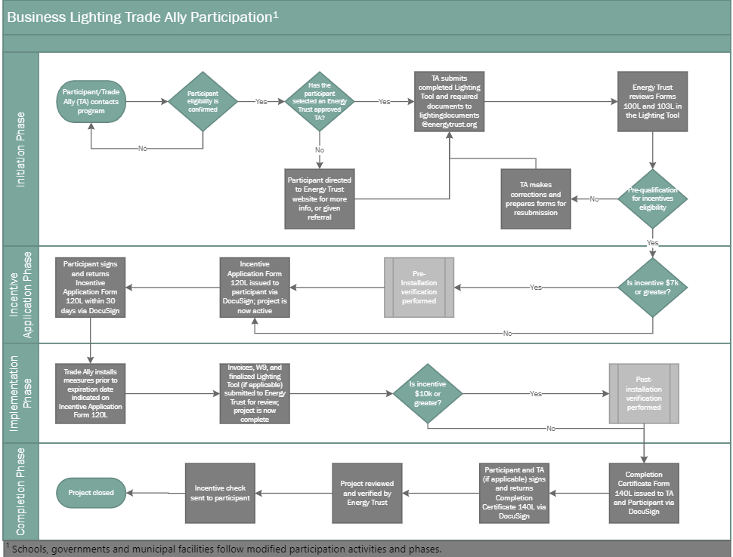
Figure 3: Business Lighting Project Processes

Initiation Phase
During project initiation, the trade ally works with an eligible participant to plan their project. The trade ally uses the Lighting Tool, plus other required documents, to specify the project and they submit these documents via email to Energy Trust at lightingdocuments@energytrust.org for review and pre-qualification to receive incentives. Other required documents include the manufacturer cut sheets and incentive payee W9 form. Trade allies must use the current version of the Energy Trust Business Lighting Tool to submit and revise incentive applications. The updated Lighting Tool for 2023 2024 will be distributed to active, enrolled trade allies in January and upon request.
Energy Trust program requirements, including incentives, are subject to funding availability and may change. Project requirements are contained within Energy Trust’s Incentives for Energy Efficient Lighting forms:
- Program Information – 190L
- Street Lighting – 190SL
- Public Sector Lighting – 190PS
- Horticulture Lighting – 490HL
Only authorized trade allies can offer Energy Trust’s Business Lighting incentives to participants for qualifying measures.

Incentive Application Phase
During this phase, Energy Trust reviews the project for eligibility per the 2023 2024 Program requirements and may perform a pre-installation verification. Program staff will contact trade allies to schedule these verifications if necessary.
If the project is eligible, Energy Trust issues an Incentive Application Form (120L) to the participant which they review and sign via DocuSign. The participant must sign the 120L form by the deadline listed on the form, which is 30 days from the Incentive Application Form (120L) Program Pre-Authorization Signature date. If the Program does not receive a signed Incentive Application Form (120L) from the participant by the submittal deadline, the Program will send a cancelation notice to the trade ally and the trade ally project queue will be open for an additional project(s) during times when an active project cap is in effect. If a participant decides not to complete a project after signing the Incentive Application Form (120L), the trade ally is required to inform the program. Resubmittal of an expired project will be subject to incentives and requirements in effect at the time of the new submission.
Measure equipment or installation services contracted for or purchased prior to Participant signing and returning the incentive agreement to Energy Trust are done at-risk and can result in a Measure being ineligible for Energy Trust incentives.
Modifications to program requirements must be approved in writing by the Program. Incentives paid will not exceed reservation amounts and trade allies will not be given additional time to submit the Incentive Application Form (120L) and the Completion Certificate (140L) forms unless expressly approved by Energy Trust in writing.

Implementation Phase
If the project scope of work or project end dates change during the implementation phase, the trade ally must notify the Program of the change so the project can be re-evaluated. The trade ally must receive written approval from the Program on the change of scope or end dates.
During the implementation phase, the trade ally installs measures and submits invoices along with a final “as-installed” Lighting Analysis and Incentives Estimates (Lighting Tool Form 103L) itemizing installed labor and materials costs for the measure(s), and all other final completion documentation to Energy Trust. In 2023 2024, the project forms and documents must be submitted before the incentive reservation expiration date, which is calculated as 365 days from the 120L Program pre-authorization date.
During this phase, projects may be subject to a post-installation verification. If so, a program representative will contact the trade ally to schedule the verification and the trade ally will assist with participant verification documentation and scheduling arrangements.

Completion Phase
During this phase, if the project is completed successfully, passes post-installation verification and all required documents are submitted on time, Energy Trust issues a Completion Certificate form (140L) to the trade ally and the participant via DocuSign. Once the 140L is signed by the trade ally and the participant, Energy Trust reviews the project and if it is approved, Energy Trust issues an incentive check to the participant or, if Option to Assign completed, to their assigned payee. Incentives paid will not exceed incentive reservation amounts and trade allies will not be given additional time to submit the Incentive Application (Form 120L) or the Completion Certificate (Form 140L) unless expressly requested by the participant in writing in advance and approved by Energy Trust in writing.

Policy Overview
Complete copies of all Energy Trust’s current Board of Director-approved policies are available for review in the “Library” on the Energy Trust website.

Confidentiality of Program Participant Information
Information submitted by Program participants is considered confidential.

Providing Information to the Participant
Business Lighting trade allies must give participants time to read and understand the terms and conditions of all incentive application forms before obtaining a signature. When providing an application to a participant for review, Business Lighting trade allies must explain, at a minimum:
- Energy Trust’s incentive rate, the incentive application and reservation process and that the project must be installed with all required project completion documentation submitted during the incentive reservation period.
- Incentive rates for a project are subject to change at any time prior to reservation, and incentive reservations for qualifying projects are subject to funding availability, expiration periods and processing procedures. The final incentive may vary from the estimate included in the initial application depending on Energy Trust’s verification of the actual system installed.
If a potential Program participant has questions about the incentive application or the process, have them contact the Program before they sign the application.

Self-Direct Participants
Under the OPUC grant agreement, Energy Trust energy efficiency programs are funded through charges for cost-effective energy efficiency collected in rates by Portland General Electric and Pacific Power Oregon law recognizes certain large retail electricity consumers that are eligible to become self-directing consumers and "self-direct" the energy efficiency charge via the Oregon Department of Energy’s self-direction program. If a self-direct eligible Program participant is submitting a lighting project to the Oregon Department of Energy to receive self-direct credits, then that project is not eligible for any Energy Trust incentives.
In addition, if a Program participant is currently self-directing that portion of the amount they are charged in rates pursuant to ORS 757.054(4) for cost-effective energy efficiency resources for the site, or decides to in the future, it can affect the amount of incentive funding they will be eligible to receive from the Program for a lighting project submitted to Energy Trust.
Self-directing participants are generally eligible for up to 50% of the incentive amount that a non-self-directing entity would be eligible to receive, or they can receive the full amount if the site stops self-directing the energy efficiency charge for a period of at least 36 months. Business Lighting trade allies should contact the Program to inquire about participant eligibility if they believe a participant site may be a large electricity user.
Energy Trust staff can support trade allies in making the determination of whether a participant has been recognized by Oregon Department of Energy as eligible for self-direction. Energy Trust may also request additional information about a participant’s self-direct status when reviewing application submittals.

PART 2: Business Lighting Trade Ally Enrollment, Performance and Expectations

Trade Ally Enrollment
To enroll as a Business Lighting trade ally, contractors must complete the online enrollment forms (1171A and 171L). Visit the Energy Trust trade ally enrollment page to begin the application process.
New trade allies must follow the “Begin” link under “New Ally Enrollment.” This will direct applicants to the “Programs List” page where contractors can select the program for enrollment. The applicable selection is “Business Lighting (Addendum 171L)” under Commercial.
Existing trade allies who wish to apply for the Business Lighting Program should contact Energy Trust to obtain their account number and enter it in the space provided and follow the instructions for the second option on the page. Energy Trust has specific insurance requirements for all Business Lighting trade allies and requires proof of insurance prior to processing an application.
The application process may take 10-20 minutes to complete. Once an application has been processed, Energy Trust will contact the references listed on the application. Upon successful completion of reference reviews, and submission and review of all required paperwork, Energy Trust will provide the contractor with written notice of approval as an Energy Trust Business Lighting trade ally.

Trade Ally Listing on Energy Trust Website
Energy Trust maintains a searchable database of all current trade allies on its website.
Trade ally website listings may include one or more “Specialties.” These Specialties reflect the sector (commercial, industrial, or multifamily) and technology of projects a Program trade ally completed in the past year.
The Program currently includes the following Specialties for Business Lighting Program trade allies:
- Lighting
- Lighting Controls
- Horticulture lighting
- Instant Discounts for Business Lighting
To maintain Specialty listings, a trade ally must install at least one project of a given Specialty each year. Specialties that are not demonstrated annually will be removed from the trade ally’s online listing.

Maintaining Trade Ally Status
Program trade allies must meet annual participation requirements each year and maintain required professional certifications to maintain their status as trade allies.
In addition, Energy Trust maintains suspension and termination policies designed to protect Energy Trust, its trade allies, and its customers from losses due to poor work quality, diminished energy savings, and health and safety issues. Energy Trust monitors the activities of trade allies on a regular basis to ensure they provide value to customers and to Energy Trust.
Energy Trust, in its sole discretion, may suspend a contractor from the trade ally network, or terminate a contractor from the trade ally network at any time. Affected contractors may be given support and opportunities for improvement, and Energy Trust may return the contractor to active status, as outlined below. At Energy Trust’s discretion, Energy Trust may require a contractor to pursue quality control process consultation at the trade ally’s expense prior to reinstatement as a trade ally.

Trade Ally Suspension
Certain actions may result in suspension from participation as a trade ally in the Program. Energy Trust will notify a contractor in writing if it has been placed in Program suspension. The contractor will have 30 days from the notice date to resolve the situation to Energy Trust’s satisfaction. Actions resulting in suspension may include, but are not limited to:
- Abusive or vulgar behavior, physically or verbally, toward customers or Energy Trust staff
- Failure to correct violations identified during the verification process within a 30-day timeframe
- Failure to follow a required Program process
- Chronic installation corrections or repeated violations of installation or Program requirements
- Failure to attend required Energy Trust trainings
- Lapsing insurance, licenses or other required certifications
- Failure to resolve any reasonable Program participant complaint regarding the contractor’s work as a trade ally under the Program
- Failure to accurately inform Program participants of current Program requirements, including but not limited to, incentive levels
- Attempting to receive lighting incentives through different program offers for the same measures

Effects of Suspension
During Program suspension, a trade ally may not submit any new incentive applications to Energy Trust, nor will Energy Trust issue any new incentive reservations for the trade ally’s projects. In addition, the suspended trade ally (i) will be removed from the searchable trade ally database on the website, (ii) is no longer authorized to use Energy Trust's logo on any materials or to represent itself as a Business Lighting trade ally, and (iii) is not allowed to apply for any cooperative marketing activities. Energy Trust may also impose other restrictions on the trade ally's participation in the Program. If the violations pertain to a specific project, the Program participant will be notified at the time of the Program trade ally’s suspension.
Trade allies must resolve violations resulting in suspension within 30 days. Failure to do so may result in termination of Program trade ally status.

Trade Ally Termination
In addition to any other termination provisions set forth in this Program Guide and in the trade ally agreement with Energy Trust, certain actions may result in Energy Trust immediately terminating a contractor as a Program trade ally. In the event of termination, Energy Trust will notify the contractor in writing. Actions resulting in immediate termination of trade ally status may include, but are not limited to:
- Failure to resolve any action resulting in suspension within 30 days
- Repeated Program violations
- Violation of license laws
- Discriminating in any case against any trade ally employee, Energy Trust employee, member of the Energy Trust Board of Directors, or member of the public on the basis of race, color, religion, creed, national origin, sex, age, familial status, sexual orientation, gender identity, disability, or status as a veteran.

Effects of Termination
Effective upon notice of termination, Energy Trust will not accept any new incentive applications, will not process any submitted incentive applications that have not yet received incentive reservations, and will remove the terminated contractor from the Program's trade ally database on Energy Trust’s website.
Energy Trust may, in its sole discretion, allow a terminated contractor to re-apply for participation in the Program at a later date. Energy Trust may require additional documentation and proof from that contractor that it has taken appropriate measures to prevent further Program violations.

